Shay Korhorn and AJ Rallo

Professor Sarkar

CS-150-01

12 December 2023

**The Wrestling Rules Handbook**

1. ***ABSTRACT***

Our project aims to inform the public about the often misunderstood and mistaken rules of wrestling. Countless people complain about not understanding the sport, which can be part of why they don’t get into it in the first place. Our code has the objective of informing people who are new to the sport of the basic rules of wrestling, and how exactly the sport we love so much works. We used class functions and many different types of coding techniques to create a code with the outcome of showing the different rules in as simple and basic a way as possible for people newer to the sport. We attempted to implement as many different types of loops and functions to create as intricate of a code as possible while still keeping it simple and comprehensible.

1. ***INTRODUCTION***

Our code has the purpose of informing people who may not know much about wrestling about the different rules so they can get a fast track into either doing the sport or becoming a fan of watching it. The goal is to ultimately improve the sport as this code will make it easier for people to understand a sport which can seem overwhelming at first. Our code changes that and makes it even easier for one to understand the sport. The reason wrestling isn’t quite as well-known of a sport as it could be is because it seems very advanced and intricate of a sport for someone to just jump into, and our code will allow someone to simply open up a computer and have the rules explained to them extremely simply.

1. ***METHODOLOGY***

We used Python, Jupyter Notebook, and the class notebooks that we created throughout the semester. We used these to create a very comprehensible and simple code that explains the rules of wrestling to anybody who wants to use our code. Our process for creating the code included starting by splitting up the different aspects of the sport into different categories. We decided to do ‘scoring’, ’outcome’, and ‘positions’. Scoring regards the different points you can earn throughout a match; Outcome is essentially standing for the different types of outcomes a match can have such as a decision or major. Finally, positions explain the different types of positions you can start and end up in during a wrestling match. We then created multiple different functions inside a “Wrestling Rules” class to split up these different categories. After that, we simply put them together with the different positions, scores, and outcomes to create a nice and simple notebook.

1. ***DESIGN AND IMPLEMENTATION***

The architecture begins with a class function with the different parts of the rules inside it. The class is called Wrestling Rules, and the different parts of the rules are positions, outcomes, and scoring. All are inside the parent class. Each of these has different aspects of the rules inside it. Each of these different categories has information in it which allows a person to choose what category they want to learn about, and it will list the information for them to read and begin to understand the sport with. We started off implementing a simple class function, and then we realized that we could make it even simpler by using a for loop and if statement to organize the different types of rules into different options you can choose to learn from.

1. ***CHALLENGES AND SOLUTIONS***

En route to our final copy of our wrestling principal handbook program, we encountered plenty of challenges yet were able to learn from them and implement updates to our code and program. An example of a challenge that we faced was under the ‘while true’ and ‘choice’ portion of our code. Every time that we would commit changes or add updates to our code, in the same spot every time we would have errors pop up regarding our ‘list’ not being callable. Therefore, we went back into the code and made sure that list was callable in the top portion of our code. We also encountered a struggle with errors that we did not know were coming from and had to restart entirely to fix it. There was a lot to be learned from this project and we have gained some insight on errors, ‘self’, and list not being callable. Even though we have met such obstacles, we were able to overcome and persevere to complete our program and we are very happy with the results.

1. ***RESULTS AND FINDINGS***

The overall outcome of this project satisfied us and is exactly how we expected and wanted it to turn out. The user can start by having a choice of 1-4, being, the scoring rules, different positions, the match outcomes, and the option to quit the program. The scoring rules will show the user the points for a takedown, escape, reversal, near fall, and penalty. The different positions consist of the neutral position, and the top and bottom positions at the begging of each period in the wrestling match. There are plenty of match outcomes, or how to win, such as winning by a decision, winning by a major decision, winning by a technical fall, and winning by a fall or pin. Finally, we have given the user the option to quit the program as for option 4.

1. ***DISCUSSION***

The significance of our project’s outcomes is to inform or help the user on different wrestling positions, scoring, outcomes, etc. To accurately inform our users on wrestling positions we made sure to list the name of the positions, such as neutral, top, and bottom. Then, to accurately inform our users on the different scoring rules and match outcomes, we also listed the names of the rules and outcomes, as well as provided a description of those rules and outcomes right next to it, when using the program. Looking back on the lessons that we learned and the area for improvement, we learned a lot. Our biggest struggle we learned from was the error stated before and how long it took to fix what we thought was a small issue. Overall, we learned to be patient and be creative when designing a program using the python language.

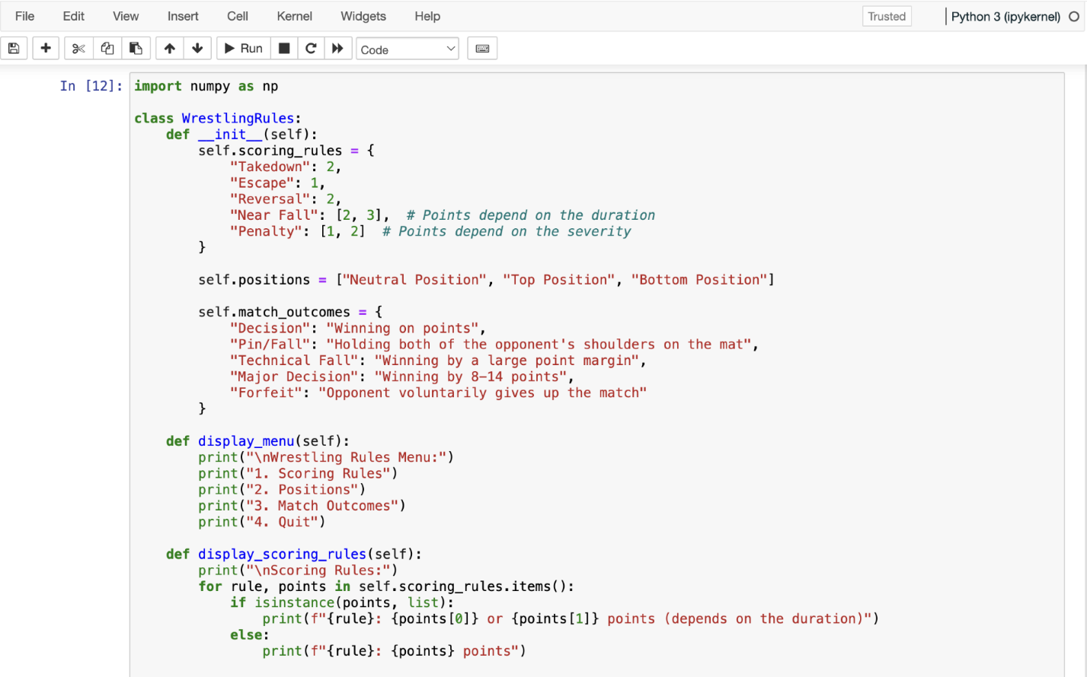

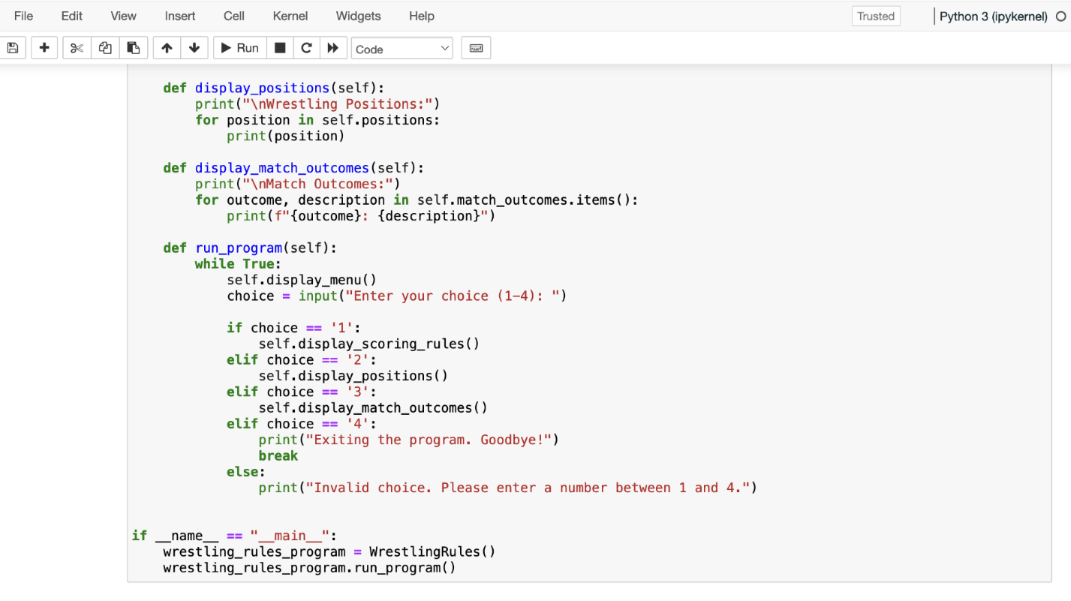

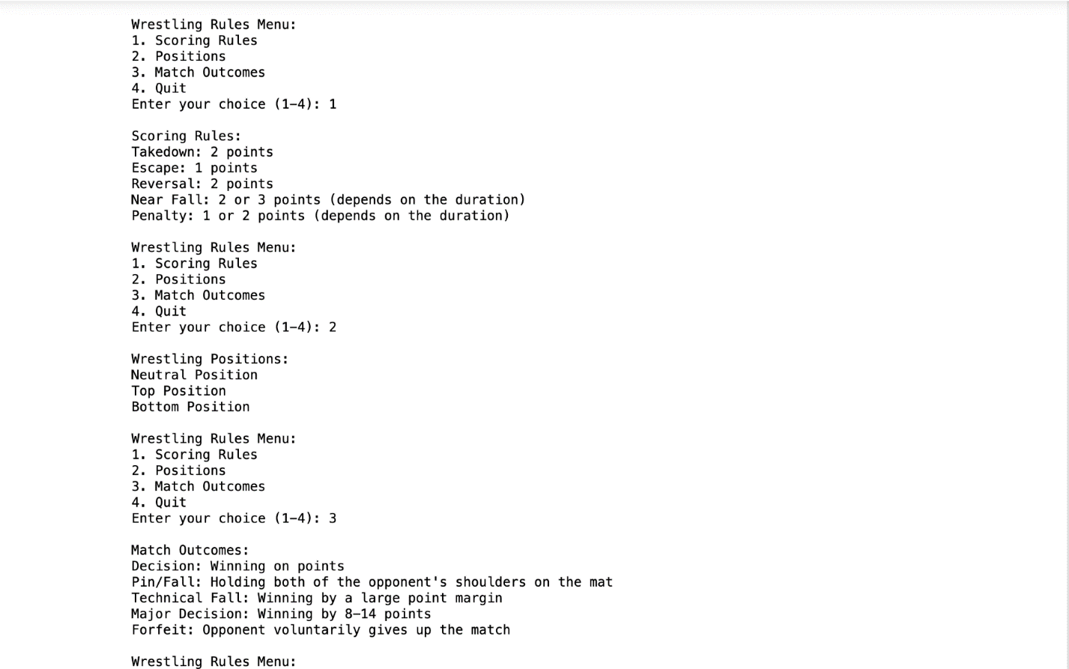

1. ***CONCLUSION***

This program allows the user to access information to everything wrestling. It has come to our attention that not a lot of people in this nation, or in the world, know a lot about wrestling. So, we have decided to help those who want to learn and are interested in the sport of wrestling. The overall impact of our project is to fully inform our users who are willing and interested to learn about the sport of wrestling.

1. ***REFERENCES***

NCAA Wrestling Rule Book Link: <https://www.ncaapublications.com/p-4671-2023-24-and-2024-25-ncaa-wrestling-rules.aspx>

Anaconda

Jupyter Notebook

Python Language

Class Materials and Class Notebooks